
Installation test procedure
Warranty registration card

Speed Log

Consist of: Part number Serial number(s)
Display unit:
Transceiver/Electronic unit:
Sensor:
Bottom parts:
Repeater(s)

Access to sensor: | (Through cofferdam, ballast tank, fore peak tank,  dry compartment, etc.

Name of vessel: |  | SKIPPER registration no:
Skipper registration no. is the number you get in autoreply by sending this completed form to warranty@skipper.no
Owner name:
Owner address:

Before placing vessel in water (Estimated duration 0,5 hours):
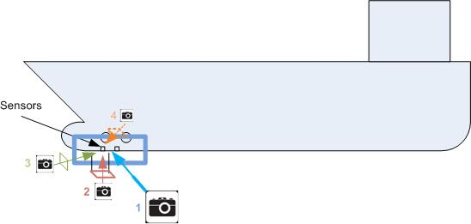
1 Document positioning of the bottom | 2 Document grinding of welding seams
3 position from forward | 4 Document inside mounting of bottom equipment  (show tubing and tank or sea valve)
- Check area around sensor is smooth, and no tape or paint on sensor.

Harbour test (Estimated duration 0,5 Hour): |  |  | Status
- Switch on log, adjust brightness & contrast to correct level and to verify function ok.
- General checkout of soft keys.
- Toggle between displaymodes.Check water and bottom track,
- Check depth on sea chart and compare with sounder function .
- Activate manual speed and adjust to 10 knots. Verify that
repeaters are displaying correct speed & distance.
- Check actual water temp. with known source and compare with DL850 readout.
- Verify that test speed is displayed on radars, conning and ecdis if connected.
Tests performed at sea (Estimated duration: 2 hours): |  |  | Status
- Verify proper operation of log, at low speed and high speed.
- Calibration results. (only first and last speed)
Heading offset
Actual speed1 |  | Measured speed1
Actual speed2 |  | Measured speed2

Comments:

Installation procedure performed / Instruction in usage given. Sign:
Date:
Name:
Position and company:
Installation procedure accepted/Instruction in usage received. Sign:
Date:
Name of responsible person:
Position of responsible person:
NOTE: This document is a warranty registration card, harbor acceptance test, sea acceptance test and installation documentation.
The document should be signed by vessels crew for acceptance tests to be valid.
The document is not an official approval of the installation and position of bottom equipment from SKIPPER Electronics.
The pictures will not automatically be checked by SKIPPER. They will be archived as installation documentation, however if we see clear errors we will comment.
By providing the pictures it may help us understand how the bottom equipment is installed. It is very expensive and time consuming to provide these pictures after vessel is launched.
A copy of the signed document with pictures should be sent to warranty@skipper.no
Or fax +47 23302271

Warranty terms:
SKIPPER gives 12 months limited guarantee on all deliveries from
SKIPPER Electronics A/S, Norway.
The guarantee period commences on the date the dealer invoices the customer provided this invoicing take place within twelve months from dispatch of the goods from SKIPPER. Our maximum guarantee period will thus be 24 months from dispatch of goods from SKIPPER Electronics A/S, Norway.
In case SKIPPER does not receive a completed guarantee card, the guarantee period commences at the date of SKIPPER?s invoice.
Under the guarantee SKIPPER will replace or repair parts which have become defective due to material or production faults free of charge to the buyer. Cost of parts and labour except overtime expenses is included in the guarantee terms while transport of parts is for the account and risk of the buyer. Should the guarantee service take place outside the premises of SKIPPER or the dealer, all travelling and living expenses will be debited the buyer. The buyer will also be debited any costs connected with docking of the vessel, emptying and steaming of tanks, diving work and other precautionary measures, which may be necessary for the carrying out of the guarantee work.
SKIPPER'S guarantee is not valid:
A:If payments have not taken place according to contract.
B:If faults occur, due to carelessness or incorrect operation of the equipment.
C:If the equipment has been rebuilt or if parts other than the original parts from SKIPPER have been inserted.
The buyer has no right to claim for any loss he might have due to faults which occur or have occurred to SKIPPER equipment.
The buyer has no right to other claims, such as cancellation, reduction in price, etc. unless SKIPPER within a reasonable time does not remedy the defect.

